TASK 1
class Person {
var name = "Naveen"
var apartment: Apartment?
deinit {
print("Person gone")
}
}
class Apartment {
var unit = "A101"
weak var tenant: Person?
deinit {
print("Apartment gone")
}
}
var person: Person? = Person()
var apartment: Apartment? = Apartment()
person?.apartment = apartment
apartment?.tenant = person
person = nil
apartment = nil

OUTPUT:
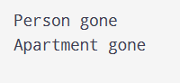

TASK 2
class Downloader {
var name = "File"
var onFinish: (() -> Void)?
func start() {
onFinish = { [weak self] in
print("Finished \(self?.name ?? "")")
}
}
deinit {
print("Downloader gone")
}
}
var downloader: Downloader? = Downloader()
downloader?.start()
downloader?.onFinish?()
downloader = nil

OUTPUT:
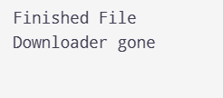

TASK 3
class Box {
deinit {
print("Box gone")
}
}
var a: Box? = Box()
var b = a
var c = a
a = nil
b = nil
print("before c")
c = nil
print("end")

OUTPUT:
